West Middle School Snack Shack
Permission Slip
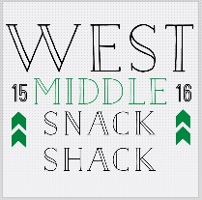

Dear Parent/Guardian:
This Semester, as a part of our Business and Marketing Curriculum, your student will take part in running the West Middle Snack Shack. During class students worked in groups to create a product pitch in order to market and sell and item for our student store. As a part of the learning process your student will help out by working in the store, taking product inventory, and calculating profit.
Each student is required to work at least one time during the semester. Workers will be dismissed from class at 2:35, in order to set up the store. Their end time will depend on transportation home, but will never go past 3:00p.m. Please indicate below what works best for your student.
Thank you for supporting our class,

Mrs. Johnson
(712)279-6813
Check out our website @ www.wmsdollars.weebly.com ______________________
Student Name: ________________________________________________________________
Class Period: _____________________________________
Date(s) signed up to work: _______________________________________________________
Time they need to be leave: __________________________
Transportation home: _______________________________

___________________________________________ _______________________
Parent signature date
Check out our website @ www.wmsdollars.weebly.com

